# Computer Organization and Architecture:

Automatic Crack Detecting System for Railway Tracks

Faculty in charge: Dr. Manish Kumar Bajpai

# **Railway Track Monitoring System:**

# **ABSTRACT:**

In this paper the problem of cracks on railway track is in structure. If these cracks were not repaired at early stages they may lead to derailment resulting in a heavy loss of life and property. The system proposed in this report automatically detects the cracks on the railway track. There are many advantages with the proposed system compared with the traditional detection techniques like less time. Minute cracks which are mostly overlooked can also be detected and repaired.

# **INTRODUCTION:**

Indian Railways is the lifeline of the nation. It is the backbone of India's economic development. Most of the people choose railways over any other mode of transport. It is the fourth largest railway networking in the world. In terms of reliability and safety we have not yet reached global standards . There have been a frequent derailments that have resulted in severe loss of valuable human lives and property.

When we go through the daily newspaper we come across many accidents in rail-road railing. Rail-road related accidents are more dangerous than other transportation accidents in terms of severity and death etc.

# **OVERVIEW:**

Analysis of the factors which causes these rail accidents recent statistics shows that approximately 60% of all the rail accidents have their cause as derailments out of which 90% is due to cracks or breaks in rails either due to natural causes like excessive expansion due to heat or due to anti-social elements.

Railway is one of the most used means of transportation.  
In the rapidly flourishing country like ours, accidents in rail road railings are increasing day by day. This project deals with one of the most efficient method to prevent railway accidents

In the current railway system, it is becoming even mere necessary to have safety element in order to prevent accidents. In recent years with the development of high speed railway, speed and capability of the trains constantly improved and traffic density gets more and more dangerous. The solution is a comprehensive tracking system, which provides accurate, dependable and timely information to the controller. It will help railways to be in a secure position and it always be useful for security purpose of the Indian railway system.

# **COMPONENTS:**

* Arduino UNO
* Motor Wheel
* Ultra sonic sensor –HC-SR 04
* Motor Driver L293

# **ARDUINO:**

Arduino is an open-source electronics platform based on easy to use hardware and software. Arduino boards are able to read inputs like light on a sensor, a finger on a button etc. and turn it into an output - activating a motor, turning on an LED, publishing something. A program for Arduino may be written in any programming language with compilers that produce binary machine code for the target processor.  Arduino can interact with buttons, LEDs, motors, speakers, GPS units, cameras, the internet, and even our smart phones.

In our simulation we integrated ultrasonic sensor and motor driver with Adriano. Based on the value from ultrasonic sensor it calculates the distance from crack and uses it to operate motor driver accordingly. We made the line at 150 cm for marking a crack and if the value crosses that, arduino deactivates the driver motor and stops the driver wheel otherwise it motor driver will be using power to make the wheel run.

# **ULTRASONIC SENSOR HC-SR-04:**

The ultrasonic sensor works on the principle of reflection of waves. We use ultrasonic sensor for crack detection in the railway tracks.

The Ultrasonic sensor sends out a high-frequency sound pulse and then times how long it takes for the echo of the sound to reflect back. The sensor has 2 openings on its front. One opening transmits ultrasonic waves, like a tiny speaker, the other receives them, (like a tiny microphone)

# **MOTOR DRIVER:**

This basically is used to regulate the power from an external power source .Here we used that to make a connection between arduino and motor wheel.

We used 12v source with this one to make the maintain rhythm with load i.e. motor in our case.

# **MOTOR:**

We used this to substitute wheel, if the line of 150 cm is crossed arduino disconnects the power to motor driver and in turn the motor, which by the way used to imitate the bot wheel. It will turn until the crack is detected.

# **CODE FOR ARDUINO :**

#define pingPin 2

#define echoPin 3

#define IN2 12

void setup()

{

Serial.begin (9600);

pinMode(pingPin, OUTPUT);

pinMode(echoPin, INPUT);

pinMode(IN2,OUTPUT);

}

void loop()

{

int duration, distance;

digitalWrite(IN2,HIGH); //To activate motor driver

long cm;

digitalWrite(pingPin, LOW);

delayMicroseconds(2);

digitalWrite(pingPin, HIGH); //To generate waves

delayMicroseconds(10);

digitalWrite(pingPin, LOW); //Generation of waves is halted

duration = pulseIn(echoPin, HIGH); // Measures time of echo

cm = microsecondsToCentimeters(duration);

if (cm > 150 && cm > 0 )

{

digitalWrite(IN2,LOW); // To deactivate motor driver

}

delay(100);

}

long microsecondsToCentimeters(long microseconds)

{

return microseconds / 29 / 2; // Returns distance(cm)

}

**SIMULATION OF CIRCUIT (PROTEUS SOFTWARE):**

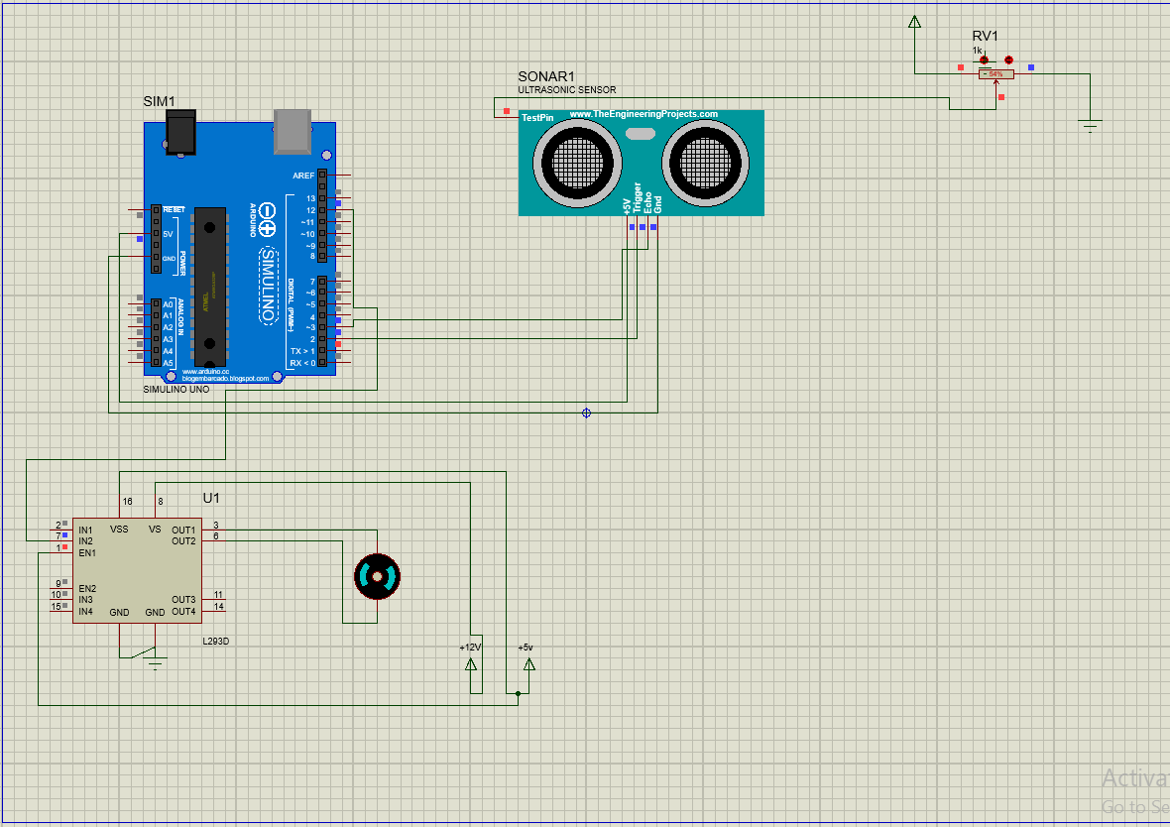

# **CONCLUSION:**

The proposed Arduino based rail crack detection system has the potential for detecting the cracks in the rail track including minor cracks automatically without any human intervention. There are many advantages with the proposed system as compared with traditional detection techniques. The advantages includes fast detect and reporting system, less cost, low power consumption and less analysis time. Also the easy availability of the components and the simplicity of idea make the proposed system ideal for implementation on a large scale with very little initial investment. Therefore it can work efficiently and effectively under working condition

# **REFERENCES:**

1. [NEWS PAPER REPORT](http://www.thehindu.com/todays-paper/tp-national/tp-kerala/students-develop-device-for-detecting-cracks-on-rail-tracks/article3916920.ece)

2. [RESEARCH PAPER](https://www.ieee.org/searchresults/index.html?cx=006539740418318249752%3Af2h38l7gvis&cof=FORID%3A11&qp=&ie=UTF-8&oe=UTF-8&q=research+papers+on+sensing+cracks+on+railway+track)